Part 1: Key Identification Exercises
Task 1.1: Superkey and Candidate Key Analysis

1. Superkeys:
1) {EmpID}
2) {EmpID, Name}
3) {EmpID, Department}
4) {EmpID, Salary}
5) {EmpID, Phone}
6) {EmpID, Name, Department}

2. Candidate Keys:
- EmpID
- SSN
- Email

3. Primary Key:
I would choose EmpID as the primary key because it is a simple,
unique identifier for each employee and does not contain personal
information.

4. Can two employees have the same phone number?
Yes, two employees could have the same phone number because Phone
is not specified as a unique identifier. In the given sample data,
however, all phone numbers are different.

Task 1.2: Foreign Key Design
Primary Key =
(StudentID, CourseCode, Section, Semester, Year)

Foreign Keys:
Student.AdvisorID → Professor.ProfID
Professor.Department → Department.DeptCode
Course.DepartmentCode → Department.DeptCode
Department.ChairID → Professor.ProfID
Enrollment.StudentID → Student.StudentID
Enrollment.CourseID → Course.CourseID

Relation B: Course Registration

1. Primary Key = (StudentID, CourseCode, Section, Semester, Year)

2. Why each attribute is necessary:
- StudentID: identifies which student is registering.
- CourseCode: identifies which course.
- Section: distinguishes between multiple sections of the same course
offered in the same semester.
- Semester and Year: together they distinguish the same course/section
offered in different terms (e.g., Fall Section 1 in 2024 vs. Fall
Section 1 in 2025) — semester name alone repeats every year, so Year
is required to make the key unique across time.
Removing any of these five attributes would make the key ambiguous:
e.g., without Section, the system couldn't tell two parallel sections
of the same course apart in the same term.

3. Additional candidate keys: none. There is no other attribute or
combination of attributes in this relation that uniquely identifies
a registration record — Grade and Credits are dependent, descriptive
attributes, not identifiers.

Task 2.1: Hospital Management System

2.1.1 Entities
Strong entities:
Patient
Doctor
Department

Weak entity:
HospitalRoom

Appointment и Prescription смоделированы как M:N-связи между Patient и Doctor
с атрибутами, а не как отдельные сущности:
- Appointment (Patient M:N Doctor): DateTime, Purpose, Notes
- Prescription (Patient M:N Doctor): Medication, Dosage, Instructions
Primary Key = (DepartmentCode, RoomNumber)

2.1.2 Attributes
Patient
Primary Key: PatientID
PatientID — simple, primary key
Name — simple
Birthdate — simple
Address — composite
Street
City
State
Zip
PhoneNumber — multi-valued
InsuranceInformation — simple
Doctor
Primary Key: DoctorID
DoctorID — simple, primary key
Name — simple
Specialization — multi-valued (doctor can have multiple specializations)
PhoneNumber — simple
OfficeLocation — simple
Department
Primary Key: DepartmentCode
DepartmentCode — simple, primary key
Name — simple
Location — simple
Appointment

Primary Key = (PatientID, DoctorID, DateTime)
Attributes:
PatientID
DoctorID
DateTime
PurposeOfVisit
Notes
Prescription
Для Prescription:
Primary Key = PrescriptionID
Attributes:
PrescriptionID — primary key
Medication
Dosage
Instructions

4. Draw the complete ER diagram using proper notation
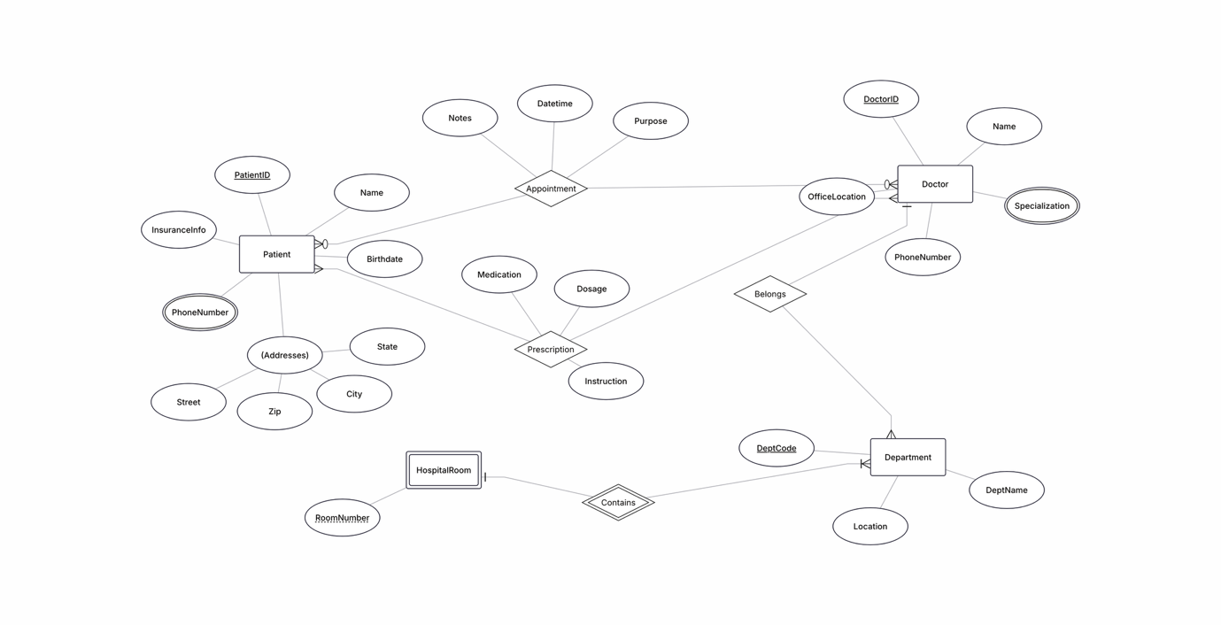

HospitalRoom (Weak Entity)
Composite Primary Key = (DepartmentCode, RoomNumber)
Attributes:
RoomNumber — partial key
DepartmentCode — часть составного primary key

2.1.3 Relationships and Cardinalities

1. Department — Doctor
Department 1 : N Doctor
Один Department может иметь много Doctors.
Каждый Doctor относится к одному Department.

2. Patient — Appointment
Patient 1 : N Appointment
Один Patient может иметь много Appointments.
Каждый Appointment относится к одному Patient.
3. Doctor — Appointment
Doctor 1 : N Appointment
Один Doctor может проводить много Appointments.
Каждый Appointment проводится одним Doctor.
Получается, что Patient и Doctor имеют M:N relationship через Appointment.

4. Doctor — Prescription
Doctor 1 : N Prescription
Один Doctor может выписать много Prescriptions.
Каждый Prescription выписывается одним Doctor.

5. Patient — Prescription
Patient 1 : N Prescription
Один Patient может иметь много Prescriptions.
Каждый Prescription относится к одному Patient.

6. Department — HospitalRoom
Department 1 : N HospitalRoom
Один Department может иметь много Rooms.
Каждая HospitalRoom принадлежит одному Department.
Это ещё раз объясняет, почему HospitalRoom является weak entity.

Task2.2
- Create a complete ER diagram
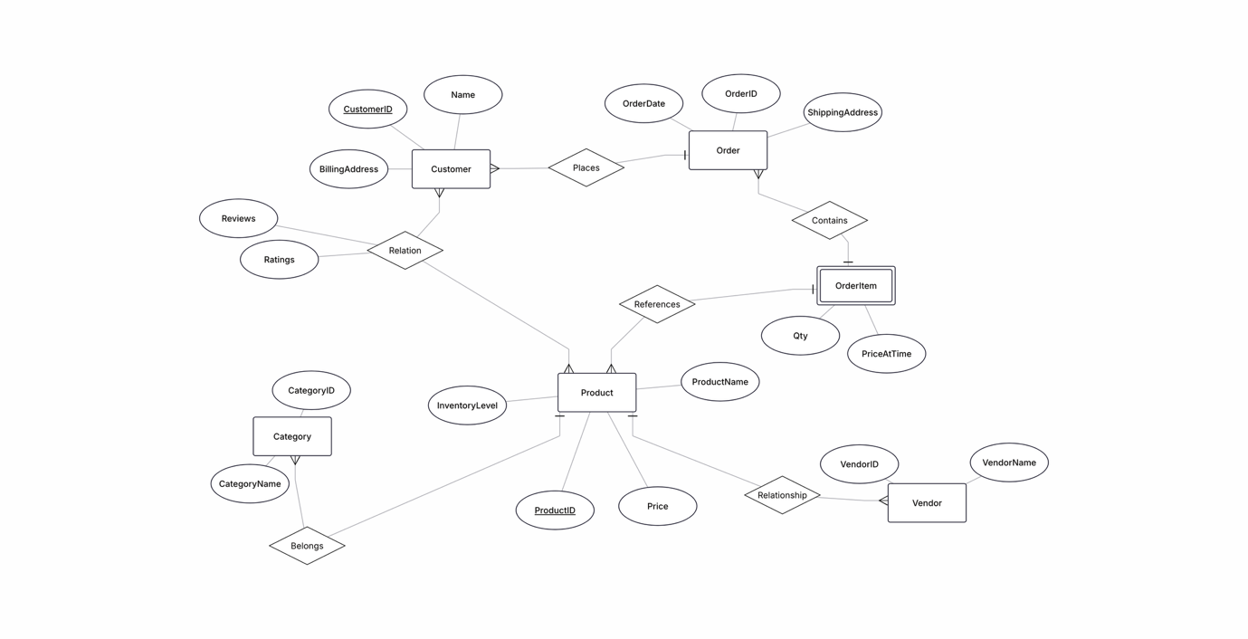

Question 2:
Identify at least one weak entity and justify why it’s weak.
Answer: OrderItem is a weak entity. Justification: It cannot exist without its strong parent entity Order. An individual order item (e.g., "line 1 containing 2 items") has no standalone identity in the business domain. Its primary key is composite and completely depends on OrderID. If an Order is deleted from the database, all its corresponding OrderItems lose their meaning and must be removed cascade.
Question 3: Identify at least one many-to-many relationship that needs attributes. Justify why they are attributes of the relationship and not of the entities.

Answer: The relationship between Order and Product (conceptually represented and split via the OrderItem weak entity).Attributes: Qty (Quantity) and PriceAtTime.Justification: These attributes do not belong strictly to a Product or an Order alone. A product's price changes over time on the storefront, so we must capture and freeze the historical price precisely at the exact moment the purchase happens. Similarly, Qty cannot be an attribute of Product (since different orders buy different quantities) or Order (since an order contains multiple different products). These facts are born only at the intersection of the two entities.

Part 4: Normalization Workshop
Task 4.1: Denormalized Table Analysis

1.

StudentID StudentName, StudentMajor
ProjectID ProjectTitle, ProjectType, SupervisorID
SupervisorID SupervisorName, SupervisorDept
{StudentID, ProjectID} Role, HoursWorked, StartDate, EndDate
2.
Redundancy: Student data (Name, Major), Project data (Title, Type), and Supervisor data (Name, Dept) are duplicated every time a student is assigned to a project. If a project has 50 students, its title and supervisor details are repeated 50 times.
Anomalies:
Insert Anomaly: We cannot add a new project or a new supervisor to the database until at least one student is assigned to that project, because StudentID is required to create a record.
Update Anomaly: If a project title changes or a supervisor moves to another department, we must update this information across multiple rows for every student assigned to that project. Missing even one row leads to data inconsistency.
Delete Anomaly: If the only student working on a specific project leaves and we delete their record, we completely lose all information about that project and its supervisor from our system.
3.
Are there any 1NF violations? No. All attributes contain atomic, single-valued cells. There are no comma-separated lists or repeating groups of columns.
How would you fix them? The table is already in 1NF. No changes needed for this step.

4. Primary key is composite: PRIMARY KEY(StudentID, ProjectID)
Partial dependencies: StudentID StudentName, StudentMajor ProjectID ProjectTitle, ProjectType, SupervisorID, SupervisorName, SupervisorDept
We split the table into three. At this stage, all supervisor details stay inside the Project table because they depend on ProjectID:
  - Student (StudentID [PK], StudentName, StudentMajor)
  - Project (ProjectID [PK], ProjectTitle, ProjectType, SupervisorID, SupervisorName, SupervisorDept)
  - StudentProjectAssignment (StudentID [PK, FK], ProjectID [PK, FK], Role, HoursWorked, StartDate, EndDate)

5.

Now we look at the newly created Project table. It is in 2NF, but it contains a transitive dependency through a non-key "mediator" (SupervisorID):
The supervisor's name and department depend on the supervisor's ID, not the project's ID.

Student (StudentID [PK], StudentName, StudentMajor)
Supervisor (SupervisorID [PK], SupervisorName, SupervisorDept)
Project (ProjectID [PK], ProjectTitle, ProjectType, SupervisorID [FK])
Assignment (StudentID [PK, FK], ProjectID [PK, FK], Role, HoursWorked, StartDate, EndDate)

Task 4.2: Advanced Normalization
1)Primary key: PRIMARY KEY(StudentID, CourseID)
2)StudentID StudentMajor
CourseID CourseName, InstructorID, Timeslot, Room
InstructorID InstructorName
Room Building
(TimeSlot,Room) CourseID
3) The table is not BCNF. According to BCNF rules, for every functional dependency X->Y, the determinant (X) must be a superkey for the entire table. In our case, there are several violations: StudentID, CourseID, InstructorID, and Room all act as determinants for other attributes, but none of them are standalone superkeys for the CourseSchedule table.
4)Student (StudentID [PK], StudentMajor)
Instructor (InstructorID [PK], InstructorName)
Classroom (Room [PK], Building)
CourseSection (CourseID [PK], CourseName, InstructorID [FK], TimeSlot, Room [FK])
Enrollment (StudentID [PK, FK], CourseID [PK, FK])
5) There is a potential loss of functional dependency checking. In the original table, we had a critical business rule: {TimeSlot, Room} -> CourseID (meaning a specific room cannot host two different courses at the same time). After decomposing the table into BCNF to remove redundancy, the attributes TimeSlot, Room, and CourseID are now separated. As a result, the database can no longer automatically enforce this rule using simple primary or foreign key constraints. This scheduling conflict check must now be handled manually through backend application logic.
Part 5: Design Challenge
Task 5.1: Real-World Application
1. Create a complete ER diagram for this system

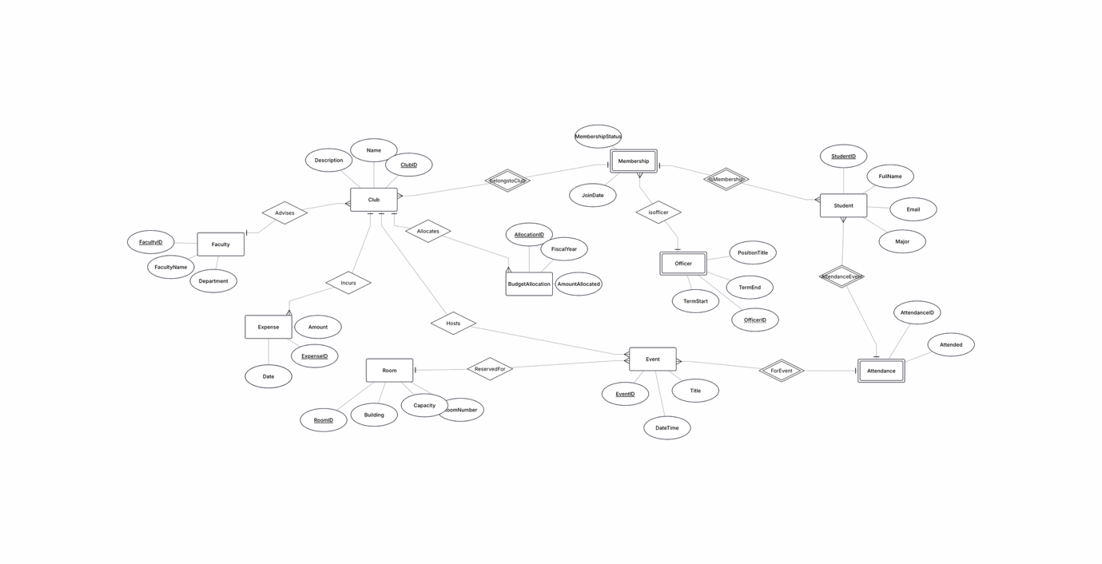

2. Convert your ER diagram to a normalized
relational schema

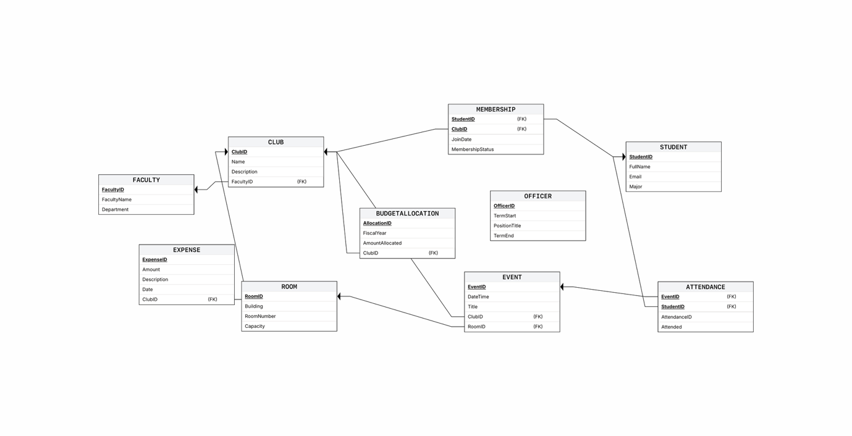

Note: OFFICER(OfficerID PK, TermStart, PositionTitle, TermEnd, StudentID FK, ClubID FK)

3. Identify at least one design decision where you had multiple valid options and
explain your choice

Decision: modeling the Officer Position as a separate entity with a surrogate key (OfficerID), rather than a composite key derived from Membership (StudentID+ClubID+TermStart).
Alternative A (rejected): Officer as a weak entity dependent on Membership, PK = StudentID+ClubID+TermStart (partial key).
Alternative B (chosen): Officer as a standalone entity, PK = OfficerID (surrogate), FK to Membership via StudentID+ClubID.
Rationale:
- A three-attribute composite key (StudentID+ClubID+TermStart) is cumbersome for external references — if another table later needs to reference Officer (e.g. "officer_approvals"), it would have to carry the full triple composite instead of a single value.
- A surrogate key simplifies updates: changing TermStart (e.g. if an officer's start date is corrected) doesn't break the primary key, whereas with a composite PK such a change would require cascading updates to every referencing table.
- Trade-off: uniqueness is no longer enforced automatically by the key structure — a separate UNIQUE constraint on (StudentID, ClubID, TermStart) is needed, otherwise duplicate officer records could be inserted.

4.Write 3 example queries that your database should support (in English, not SQL)

1) "Find all students who are officers in the Computer Science Club" — join STUDENT → MEMBERSHIP → OFFICER, filtered where CLUB.Name = 'Computer Science Club'.
2) "List all events scheduled for next week with their room reservations" — join EVENT → ROOM, filtered where EVENT.DateTime falls between next Monday and Sunday.
3) "Show total expenses versus allocated budget per club for the current fiscal year" — join CLUB → EXPENSE (sum Amount) and CLUB → BUDGETALLOCATION (AmountAllocated), grouped by ClubID, filtered where FiscalYear = current year.

